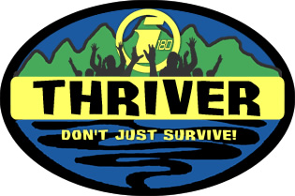

Name: _____________________________________________________________________ (Please Print)
Grade: __________ School: ______________________________________________________________
I agree to the following:
- To respect my leaders and peers at all times.
- To respect nature while we are camping.
- To follow and abide by all of the rules of this adventure.
- To give every aspect of this adventure my very best – and with a good attitude.
- To be honest to my leaders and peers during debrief and interview times each day.
- To keep everything that happens on this trip confidential until the Kick-Off Series is finished this October. (To not spoil anything for the rest of the youth group.)
Signature: _________________________________________________________ Date: ________________
Please explain why you are interested in being a part of this experience:

________________________________________________________________________________________

________________________________________________________________________________________

________________________________________________________________________________________

________________________________________________________________________________________

________________________________________________________________________________________

________________________________________________________________________________________

*** To be considered for this adventure, you will need to find 6 sponsors who will support you in your decision to take part in this. These individuals must be members of this church and cannot be family. Please get the sponsors to sign and date the back of this sheet prior to turning it in. (These individuals are just signing off that you have discussed this with them and they feel that your heart is in it. AKA, cheap advertisement :)

Individuals may only sponsor one person for this event.

