Oct 10

Behind the gate, I hold the old skins that still stand for us today… where weather cannot harm and man cannot touch our charters.

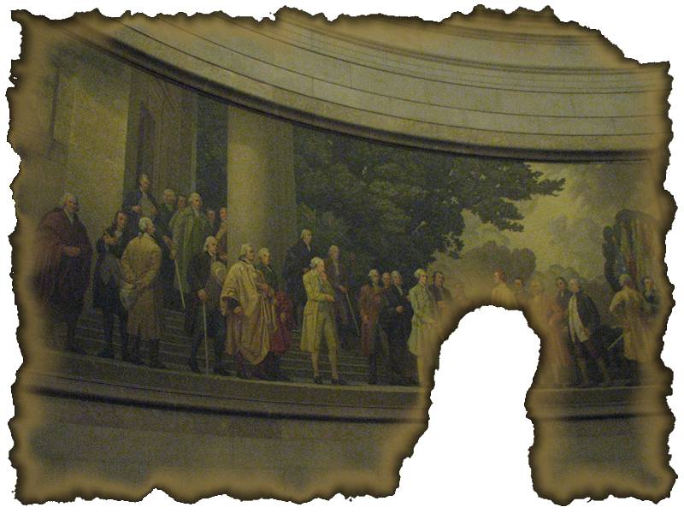
But when a long train of abuses and ________, pursuing invariably the same Object evinces a design to reduce them under absolute ________, it is their right, it is their duty, to throw off such Government, and to provide new Guards for their ________ security.

U – __ – U – __ – __ – A – __ – __ – __ – N – S
5a 5b 5c 5d 5e 5f

__ – __ – S – P – __ – __ – __ – __ – M
5g 5h 5i 5p 5j 5k

__ – __ – T – __ – __ – E
5l 5m 5n 5o
Each House shall be the Judge of the ________, ________ and ________ of its own Members, and a Majority of each shall constitute a Quorum to do Business...

__ – L – __ – C – __ – __ – __ – N – S
6c 6d 6e 6a 6b

__ – E – __ – __ – R – __ – __
6f 6h 6g 6i 6j

Q – __ – A – __ – __ – F – __ – C – A – __ – __ – O – N – S
6k 6l 6m 6n 6o 6p

