Oct 17

A place where they rule on the Rules in this age of man, but on the eastern side will be held up high forever by this great exemplar of law…

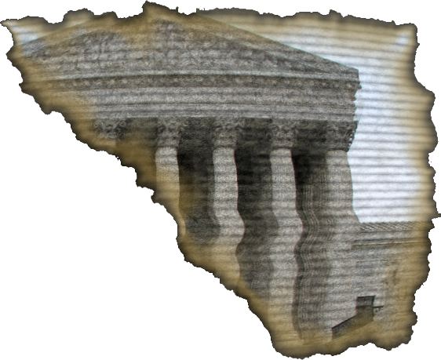

Holding the Rules is…

__ – O – __ – __ – S
7a 7b 7c

