Oct 24

Next to the tree of peace from the Six Nations, a building stands for methodists united at Maryland and First.

Our denomination shares the same founders, the Wesley brothers…

J – O – __ – N __ – N – D C – __ – __ – __ – __ – __ – S
8a 8e 8c 8f 8d 8g 8b

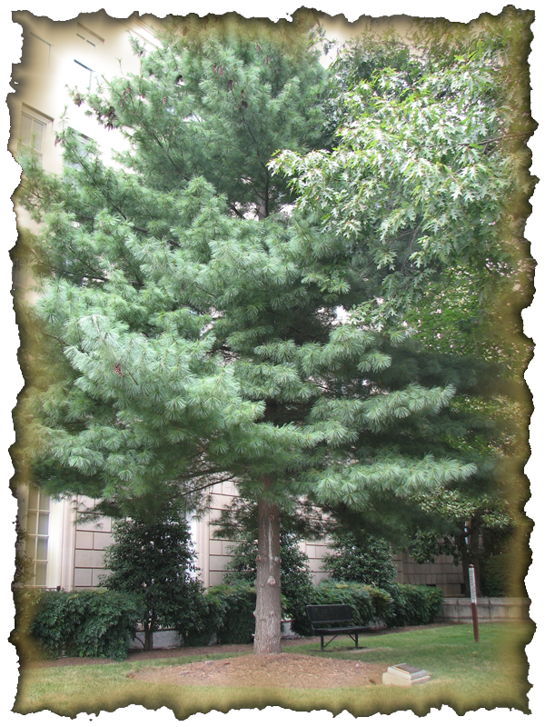
The tree of peace reads, “Dedicated by General ________ of ________ and Society ________…”

B – O – __– __ – D
9f 9g

__ – __ – U – R – C – H
9e 9a

S – __ – __ – __ – __
9b 9h 9c 9d

