Oct 3

Today I saw a lady with a golden spear, surrounded by great words written on the walls. She points downward toward this great book through the floor, behind the hall with 64 giant pedals beneath your feet.

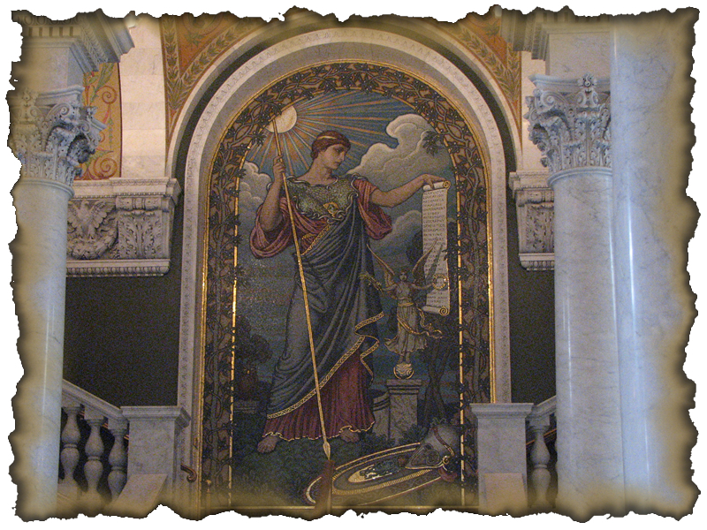
This item represents the first time this Word was pressed…

__ – U – __ – __ – __ – __ – E – __ – __ __ – __ – __ – L – __
3a 3b 3k 3c 3j 3d 3e 3f 3g 3h 3i

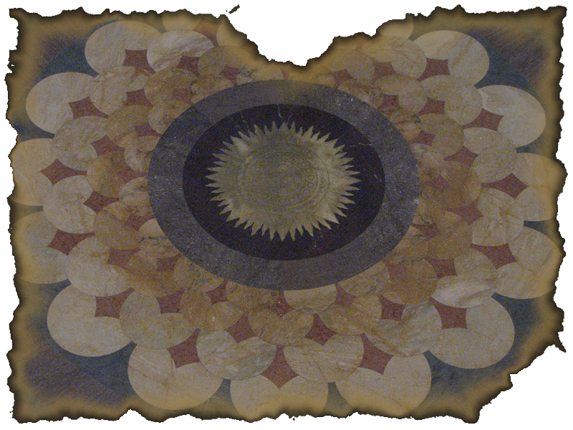

THERE IS BVT ONE TEMPLE IN THE VNIVERSE AND THAT IS…

__ – __ – __ B – __ – __ – Y __ – __ __ – __ – __
4a 4b 4c 4d 4e 4f 4g 4h 4i 4j

