Sept 26

You won’t need gumgum for me to help you… I stand with frozen expression on “resurrection” island. Read about my maoi brothers to find our true substance.

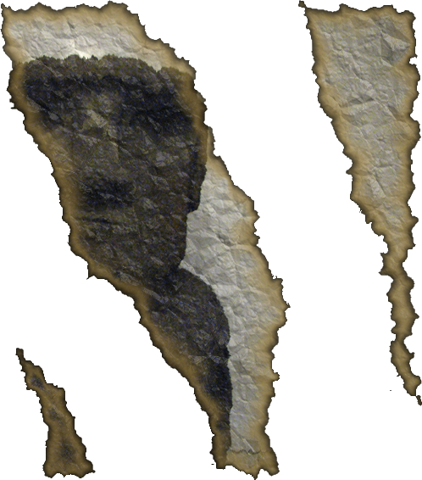

My true substance is “consolidated…”

__ – __ – L – __ – A – __ – __ – C __ – __ – H
2a 2b 2c 2d 2g 2e 2f

