Milton HS - Hurdler “Meeting”

When: Sunday, March 16th, 2pm - ???

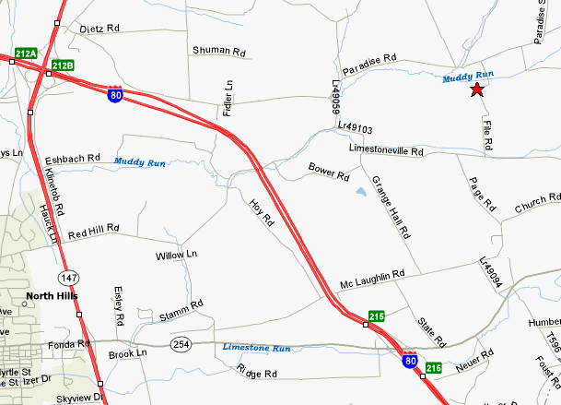

Directions to Coach Kendall’s house:

- Take the Broadway exit off 147
- Head away from town on 254 (towards I-80)
- Turn left onto Stamm Rd.
- Stay left around corner onto Muddy Run Rd. (just past our church)
- Stay on Muddy Run Rd. until you come to Paradise Rd.
- Turn right onto Paradise Rd.
- Turn right onto File Rd. (next road on right - about 1 mile)
- Look for mailbox #565 on the right side of the road (4th house)
- You’re there!

Call if you get lost… home: 742-0410 cell: 772-5586

*** We can give you a ride home if you need one. ***

