Sprint Hurdles Photo Sequence
All good sprint hurdlers must be fast sprinters. An efficient hurdle clearance technique is essential, but fast times are produced through quick running between the hurdles.
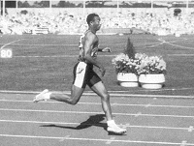  1 | The athlete approaches the hurdle with good sprinting style, hips high
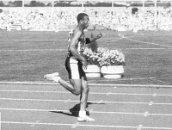
2
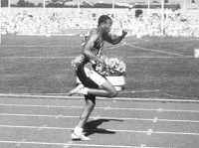  3 | The lead leg knee must be picked up fast and driven at the hurdle  The lower part of the lead leg is left low and extends once the knee reaches the height of the hurdle  The lead leg knee must be picked up in line with the vertical centre line of the body  There should be no tendency for the lead leg knee to be pulled across the body or for the lower leg to go out and round  The lead leg folds at the knee, whilst the trailing leg is still driving the hurdler forwards into an active take off  The left arm (the arm opposite the lead leg) is very active, whilst the right arm "sleeps"  The trailing leg drives the body at the hurdle as the lead leg rises  As the lead knee and thigh drive upwards, the trunk dips  This is the beginning of the "lay out" over the hurdle
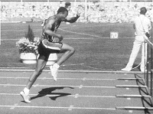
4
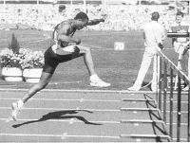
5
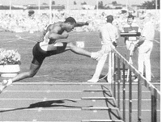  6 | The athlete does not "float" over the hurdle in this phase  As soon as the lead foot passes the hurdle, it begins its fast descent to the ground  During this phase, the trail leg is moving quickly assisted by the left arm driving back  Athletes should think of the trail leg knee pulling the foot through vigorously
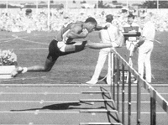
7
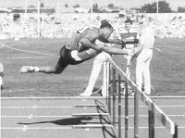
8
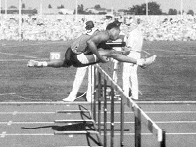  9 | As the heel of the lead leg passes the barrier it must be pulled down and back to land under the body  There is no necessity for the lead leg to be straight over the top of the hurdle  The athlete should feel the trailing knee sweeping wide and flat over the hurdle  As the trailing leg crosses the hurdle, the foot must be cocked at the ankle so that the foot does not hit the barrier  The lead leg straightens as it descends towards the ground  The right arm becomes more active as the athlete leaves the hurdle in frames 11 and 12
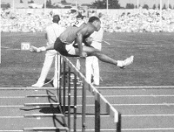
10
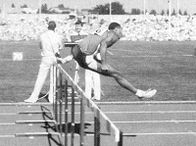
11
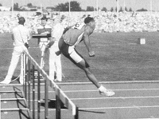
12
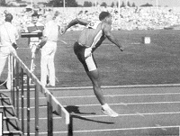  13 | After crossing the barrier the trailing knee continues to rise and comes round in front of the body  As the athlete reaches the ground with the lead leg, sprinting is resumed  The hips must not sink as the athlete lands.  Frames 15 and 16 show an excellent return to sprinting form, with active arms
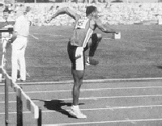
14
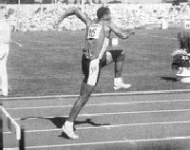
15
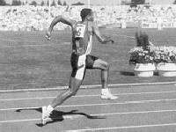
16

