Sprint Hurdling Technique
Hurdling is, because of its technical and energy demands, an exciting and challenging event. The technical component of hurdling is clearly much greater than in sprinting, yet the concept of the hurdles race must be one of a sprint, with adjustment for each hurdle. The stride pattern for effective sprint hurdling is a 7 to 8 stride pattern to the first hurdle followed by a 3 stride pattern between the hurdles.

The Start and Approach

In sprint hurdling the first hurdle is only some seven or eight strides away so the athlete must come upright at the 3rd or 4th stride, much earlier than the sprinter. To enable this to happen the block spacing will have to be slightly altered. When using an eight stride approach the take-off foot is placed in the front block. Whether using a seven or eight stride pattern to the first hurdle, in each case the take-off should occur from 6 1/2 - 7 1/2 feet from the hurdle.

Hurdle Clearance
The athlete must attack the hurdle and aim to clear it as quickly and efficiently as possible, raising their centre of gravity only a little more than in a normal sprint action.

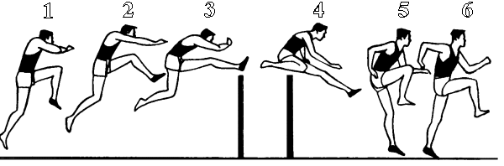

Leg Action
The last stride of the approach to the first hurdle is shortened in order to allow the take-off leg to move rapidly under the hips. This ensures that a fast effective drive can be made across the hurdle. [1].

Action of the lead leg:
- The knee must be picked up fast [1]
- The knee must be picked up in line with the vertical centre line of the body.
- The lower part of the leg is left low and extends once the knee reaches the height of the barrier [1] & [2]
- The heel is driven out just over the hurdle [2] & [3]
- The knee should not be pulled across the body and the lower leg should not go out and round.
- The knee of the lead leg is slightly bent [3]
- As the heel of the lead leg passes the barrier it must be snapped down to land under the body [3] & [4]
- The leg straightens as it descends towards the ground [4]
The uppder body leans forward into the hurdle to aid in sustaining momentum after the hurdle is cleared. The eyes remain looking forward to the next hurdle. If the body is held too upright on the clearance, the hurdler will have to raise his center of gravity higher to clear the hurdle. This will also cause the hurdler to be leaning back upon clearance, destroying momentum.
Action of the trail leg:
- The trailing leg drives the body at the hurdle as the lead leg rises [1]
- The recovery of the trail leg must begin from well behind the body if the drive is to be completed
- The athlete should feel the trailing knee sweeping wide and flat over the hurdle [4].
- As the leg crosses the hurdle, the foot must be cocked at the ankle [4]
- After crossing the barrier, the knee continues to rise and comes round in front of the body [5]

Many hurdlers have a tendency to drop the trail leg after it has crossed the barrier. This has the effect of making the first stride short and pulling the athlete off balance. The trail leg must be pulled through high and fast so that the first stride is fast. This is essential in maintaining proper steps between the hurdles.

Arm Action
As in sprinting, the arms act to balance the body and counter the rotations produced by the legs. The arm opposite to the lead leg actually leads the action into the hurdle and pushes/dives forwards as the lead leg rises [1]. The arm should be brought up and across the body to lengthen the arm motion to match the longer hurdle stride. The other arm should be taken back in a normal sprinting action. As the trail leg comes round the leading arm sweeps around the knee to counter the rotation of the trail leg [4].

