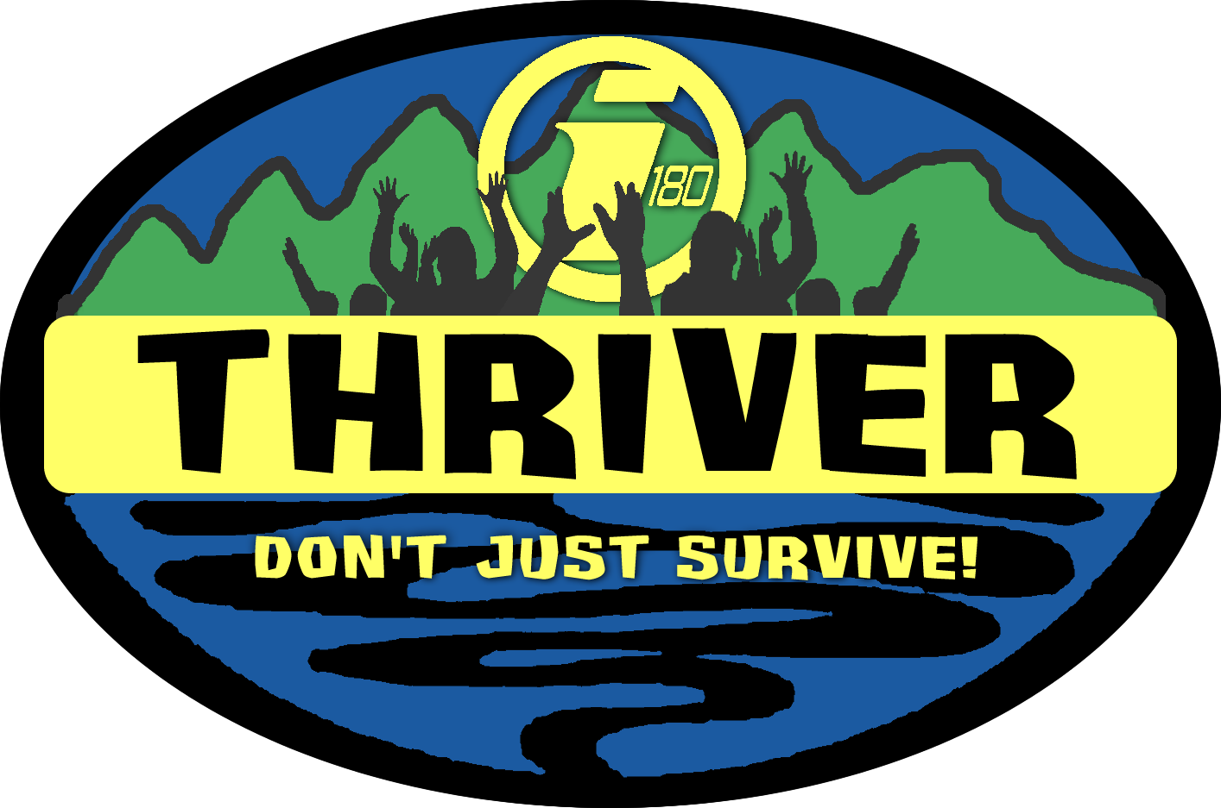

HEALTH FORM

NAME D.O.B. TELEPHONE

ADDRESS

Name of Family Physician Telephone

Health Insurance Co. Policy # Group #

Is your teen in general good health? Yes No Presently taking any medication?

If so, list what is being taken

Please list any limitations on activities

Allergies (check any that apply to your teen):

Hay Fever _____ Convulsions ______ Asthma _____ Fainting _____ Sulfa _____

Poison Ivy (state degree) _____ Penicillin _____ Bee Sting _____

Food allergies _______________________________________________________________________________________

Other drug allergies (name) Other allergies

If allergic to any of the above, please indicate any medications that your teen is using presently for the stated condition:

==========================================================================
I certify that the above information is correct, and that my teen has my permission to participate in the THRIVER: Survival Camp, except as noted above. In case of medical emergency, I understand every effort will be made to contact parents or guardians of the teen. In the event I cannot be reached, I hereby give permission to the physician selected by the I-180 staff to hospitalize, secure proper treatment for, and to order injection, anesthesia, or surgery for my teen, as named there in.

Parent or guardian signature Date
==========================================================================Should an emergency arise during the THRIVER: Survival Camp and a parent/guardian is unable to be contacted, give TWO names, addresses and telephone numbers, where persons responsible for the teen may be reached.

1) Name: Telephone:

Address:

2) Name: Telephone:

Address:

