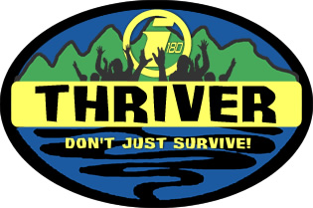
Main Entry: thriver
Pronunciation: 'thrI-v&r
Function: noun
1: one who vigorously grows; FLOURISHES
2: one who gains in wealth or possessions; PROSPERS
3: one who progresses toward or realizes a goal; DRIVEN
What happens when eight youth are forced to survive for an entire week in the wilderness?
No food... No shelter... No mommy... Nothing but a knife, a canteen, and a Bible for five days as two teams survive in a remote wilderness!
This series is going to look at the impact others have on our lives and the impact we can have on them. The popular reality TV series Survivor puts ordinary people in a survival challenge that focuses on exploiting others to win a prize. We believe that the purpose of our lives isn't survival, but to thrive in Christ. Thriver is going to take eight of our youth and put them in the same situation as Survivor with a twist. Unlike most reality TV shows, Thriver will reward teamwork and teach us all a valuable lesson... there is a big difference between surviving and thriving in this world!

THRIVER: Survival Camp Details:

When: August 21st – 27th (We are leaving at 6:00am on the 21st and will be home for church on the 27th.)

Where: UNDISCLOSED (We will let your parents know exactly where we are, but it is a surprise to you. There will be contact possible between your parents and the leaders for the entire duration of the trip.)

What to Bring: Fishing license (everyone over the age of 16 will need one), clothes, sleeping bag, overnight things for the first night (training), military issue shirt and pants (BDUs) for the 5 survival days, boots, and your favorite snack to share with 12 people. Everything else that you will need will be issued at camp. (Exceptions are made for any health and safety items, such as inhalers, medications, etc.)

What to Expect: 1 intense day of survival training (boot camp), 5 days of team survival in the great outdoors, challenging competitions, and an experience you will never forget! All of this will be video taped and shown throughout our THRIVER Series this fall.

